CS 499 Milestone Two Narrative
Artifact Description
The artifact I selected is the WeightTracker Android mobile application that I originally created in CS 360 Mobile Architecture and Programming in 2025. The original application allowed a user to create an account, log in, set a goal weight, record daily weight entries, and edit or delete those entries. It used Java, Android XML layouts, and a local SQLite database. The original project was functional and demonstrated basic mobile application development, user interaction, persistent storage, and create, read, update, and delete operations.
For this milestone, I enhanced the artifact into a Cardiac Rehab Progress Tracker. The enhanced version keeps the original account and goal-weight foundation, but it changes the main purpose of the application from tracking only weight to recording a broader fictional cardiac rehabilitation session. A session can now include the date, exercise minutes, weight, resting heart rate, target heart-rate range, systolic and diastolic blood pressure, and optional notes. The dashboard displays the most recent measurements and a history of saved sessions, and each session can be added, edited, or deleted.
Justification for Including the Artifact and How It Was Improved
I selected this artifact because it provides a clear example of my growth as a software developer. The original version worked, but much of the application logic was concentrated in HomeActivity. That activity was responsible for loading database records, building interface rows, handling edits and deletions, updating goals, and checking notifications. This structure was reasonable for the original course assignment, but it would become difficult to maintain as the application expanded. The artifact gave me an opportunity to show that I can evaluate an existing design, identify limitations, and improve the software without starting over.
The largest design improvement was separating responsibilities into clearer components. I added a RehabSession model to represent one session as a complete object instead of passing unrelated values throughout the activity. I added a RehabSessionRepository to contain the session-related SQLite operations, which keeps persistence code out of the user-interface layer. I also created a RehabSessionValidator so the rules for dates and numeric values are centralized and can be tested independently. HomeActivity now focuses mainly on coordinating the dashboard, responding to user actions, and displaying the data returned by the repository.
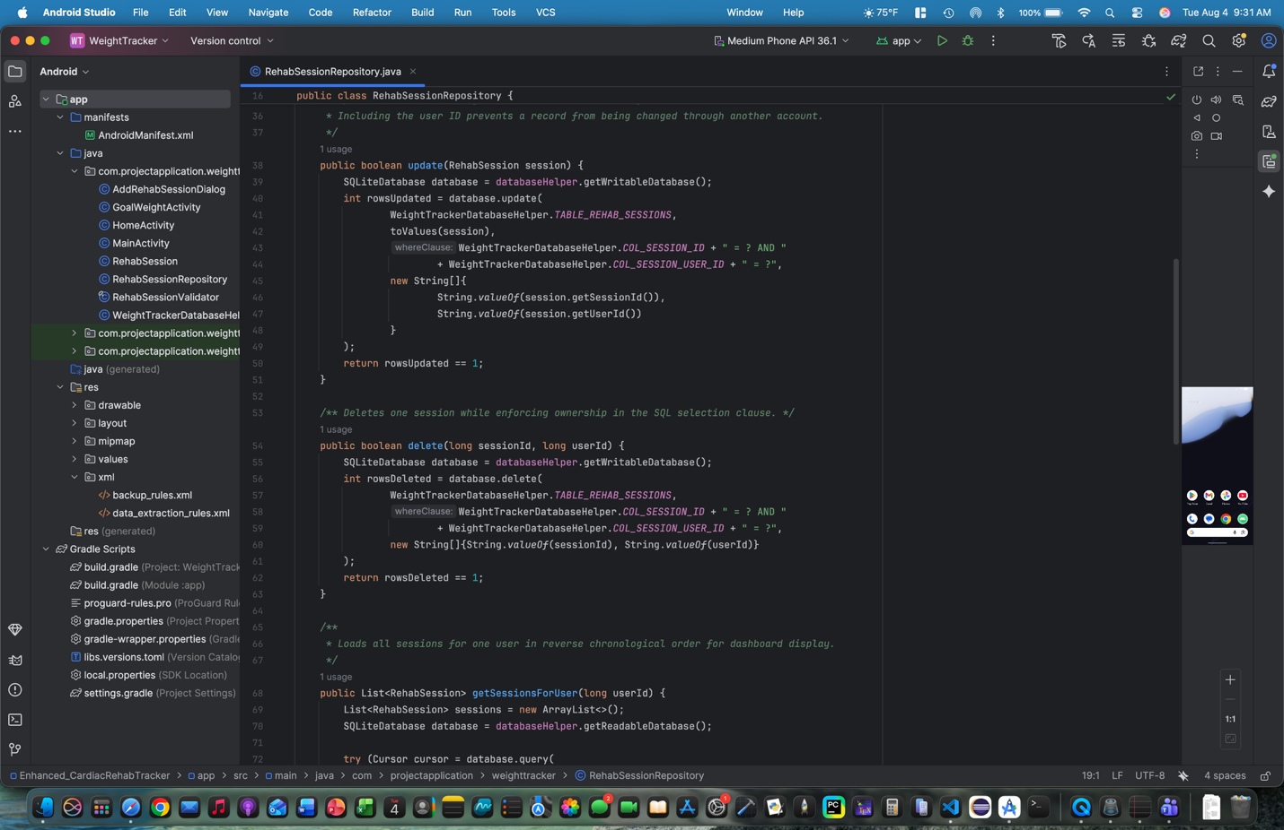
Figure 1. The repository layer isolates rehab-session persistence from the user-interface logic and scopes operations to the active user.
I also redesigned the user workflow. The original home screen displayed a weight table and several weight-specific controls. The enhanced dashboard provides summary cards for the current weight, goal weight, latest exercise minutes, and latest resting heart rate. Below the summaries, the application displays complete rehab-session cards with the session date, exercise time, weight, heart-rate values, blood pressure, notes, and edit or delete actions. This design makes the purpose of the application easier to understand and better matches the healthcare-focused use case I planned for my ePortfolio.
Input handling was another important improvement. The original app mainly checked for empty fields and whether a weight value could be converted into a number. The enhanced validator checks that the date uses the YYYY-MM-DD format and is not in the future. It also checks reasonable application limits for exercise minutes, weight, resting heart rate, target heart-rate values, blood pressure, and note length. It verifies that the lower target heart rate is less than the upper value and that systolic blood pressure is greater than diastolic pressure. The add and edit dialog overrides the normal positive-button behavior, so invalid input does not close the form and force the user to reopen it.
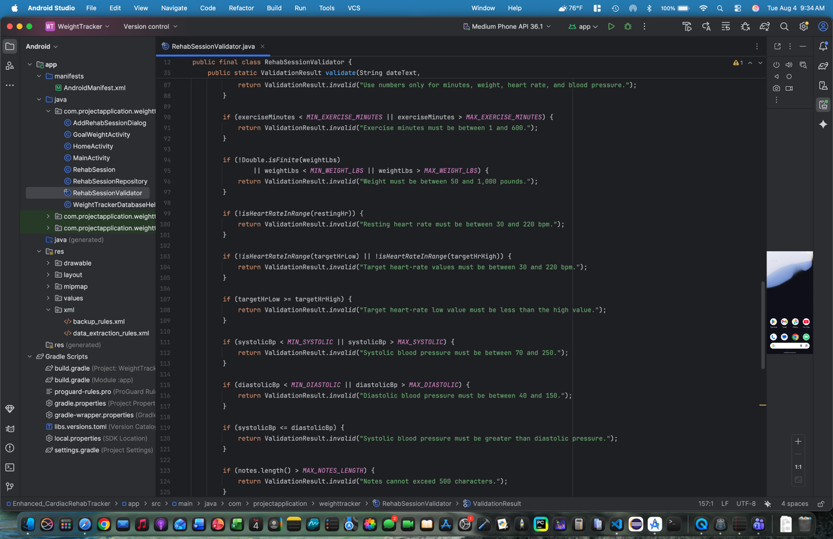
Figure 2. Centralized validation checks dates, heart-rate ranges, blood-pressure relationships, and other session values before storage.
The enhancement also addresses unnecessary permissions and maintainability concerns. I removed the SMS permission, notification activity, and related interface because the app did not actually need access to text messaging for the redesigned workflow. User-facing text was moved into Android string resources instead of being repeated as hard-coded text. Finally, I added unit tests for the validation class to check valid input, incorrect date formats, reversed target heart-rate ranges, invalid blood pressure relationships, unrealistic weight values, and goal-weight validation.
Course Outcomes Addressed
The enhancement made substantial progress toward the course outcomes I selected in Module One: outcomes 1, 2, 4, and 5. For outcome 1, the redesigned dashboard organizes several types of progress information in a format that can be understood by users with different levels of technical knowledge. The model, repository, validator, comments, and project documentation also make the code easier for another developer to review and extend. These improvements support collaboration and make the information more useful for future decision-making.
For outcome 2, the interface, code organization, code review, narrative, and ePortfolio presentation communicate the purpose of the artifact to both technical and nontechnical audiences. The interface uses clear labels and groups related information, while the narrative explains the design decisions and limitations without requiring the reader to understand every line of Android code.
Outcome 4 is the strongest match for this milestone. I used Android development tools and established software-engineering practices to turn a basic weight tracker into a more complete healthcare-focused application. The enhancement includes a new workflow, expanded functionality, modular classes, reusable validation, cleaner resource management, safer permission choices, and tests. Together, these changes deliver more value than simple debugging or comment cleanup because they significantly change what the application can do and how the code is structured.
For outcome 5, I demonstrated a security and privacy mindset by removing the unused SMS permission, validating data before it is stored, limiting notes, and keeping session operations tied to the current user ID. I did not treat this milestone as the final security or database enhancement. Password hashing, formal foreign-key enforcement, a normalized database structure, and more advanced migration work remain planned for the remaining categories. Keeping those items for the database milestone prevents this enhancement from replacing the separate work I still need to demonstrate later.
Reflection on the Enhancement Process
The most important lesson from this enhancement was that adding features is only one part of improving software. The original app could have been expanded by placing more code into HomeActivity, but that would have made the project harder to understand and maintain. Creating separate model, repository, validation, dialog, and activity responsibilities required more planning, but it produced a clearer structure and made each part easier to test or change. I also learned that improving an existing application requires attention to compatibility. Instead of deleting the original database tables, the enhanced database moves to version two and adds the rehab-session table while preserving existing users and weight records.
One challenge I faced was deciding how to validate health-related values responsibly. The application needs to prevent obvious bad input, but it should not present academic validation ranges as medical guidance. I addressed this by using broad limits that mainly detect impossible or clearly unreasonable entries. Given my background in healthcare, I was able to determine appropriate limits for each entry. In a real healthcare product, these requirements would need to be reviewed by clinical, legal, security, and usability stakeholders before release.
Overall, this milestone improved both the visible application and the underlying design. The enhanced artifact now demonstrates mobile interface design, object-oriented modeling, separation of concerns, repository-based data access, validation, CRUD functionality, testing, permission reduction, and healthcare-focused workflow planning. It is a stronger ePortfolio artifact because it connects my computer science skills with my professional experience in cardiac rehab and shows how I can take an existing project, identify weaknesses, and develop it into a more organized and useful software solution.

